Act II Scene 1 – Exploring Sound and Hearing
Name
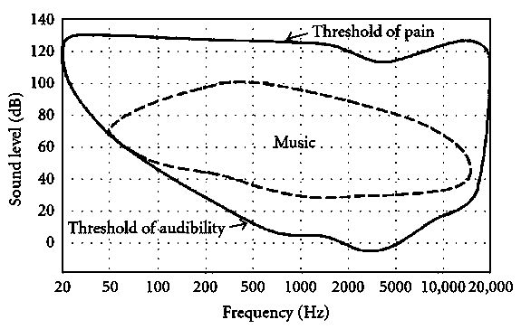
Use the chart at the right for the first four questions.
- Could you hear a 100 Hz sound at 20 dB? no
yes
- Could you hear a 1000 Hz sound at 20 dB? no
yes
- Based on the chart, a 2000 Hz sound at zero dB is right on the threshold of audibility, and so is a 12,000 Hz sound at 20 dB. How much more intense is the 20 dB sound than the one at zero dB?
They are the same intensity.
The 20 dB sound is 10 times more intense.
The 20 dB sound is 20 times more intense.
The 20 dB sound is 100 times more intense.
- Again based on the chart, how would you judge the apparent loudness of those two sounds(2000 Hz at zero dB and 12,000 Hz at 20 db)?
They would seem the same (very faint) loudness.
The 20 dB sound would seem 10 times louder.
The 20 dB sound would seem 20 times louder.
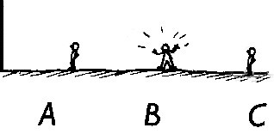
The 20 dB sound would seem 100 times louder.
5)
Three guys are standing in a line, 10 m, 20 m, and
30
m away from a vertical wall, respectively. Guy B
shouts. (I wonder why?*) Will he be able to hear his
own echo?

n0

yes

It depends on the pitch of his voice.
* This reminds me of my all-time favorite joke. Choose any three things that can walk, and the more different they are, the better. It’s good if at least one is a priest or a rabbi. Suppose I choose an astronaut, a rabbi, and a duck. Then here’s the joke: “An astronaut, a rabbi, and a duck walk into a bar. The bartender says, ‘What is this, some kind of joke?’”
For all of these questions, use the internet to find good answers.
- What animal can hear the highest frequencies?

- Fungo Squiggly, at the right, is a recurring character in the“Get Fuzzy” comic strip. Follow this link to a Wikipedia page: https://en.wikipedia.org/wiki/Hearing_range According to the table under the heading “In animals,” what is so surprising about the hearing range of ferrets?
–
getfuzzy.wikia.com
- Again from that same table, what do most birds seem to have in common about their hearing?

– deviantart.com
9)
How fast does sound travel (in m/s) in dry air at
zero Celsius?
10) Who was one of the first people to measure the speed of sound? When was that?

Act II Scene 2 Homework – Exploring Harmonics
Name
For each of the ‘frog-on-a-post’ waves on the left, match it with the Fourier analysis graph of that wave on the right and with the source, at the bottom. (Hint: Refer to the PowerPoint show, Interpreting Sound Spectra.)
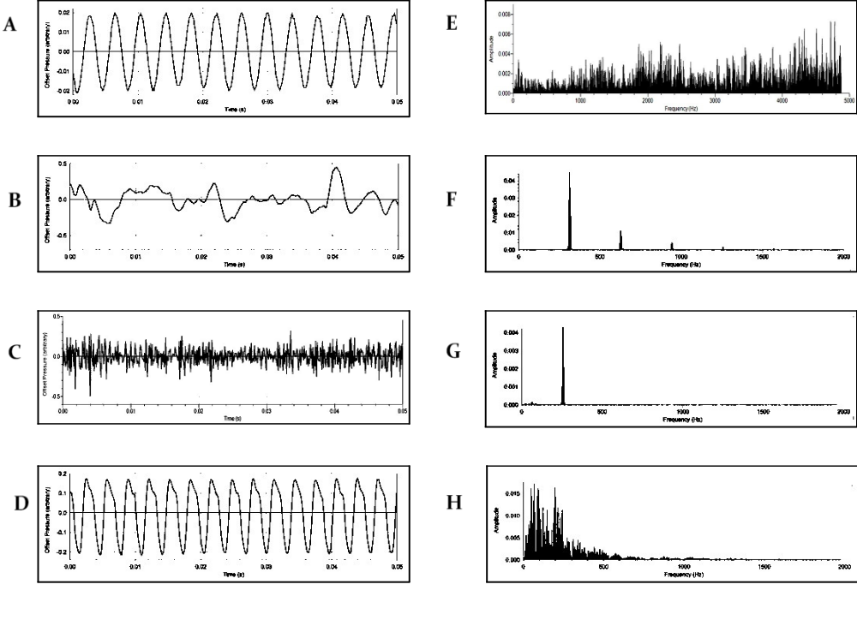
- Which two are of a tuning fork? 3) Which two are of an office fan?
A. E. B. F. C. G. D. H. A. E. B. F. C. G. D. H.
- Which two are of an organ pipe? 4) Which two are of a person hissing an ‘ssss’ sound?
  - E. B. F. C. G. D. H. A. E. B. F. C. G. D. H.

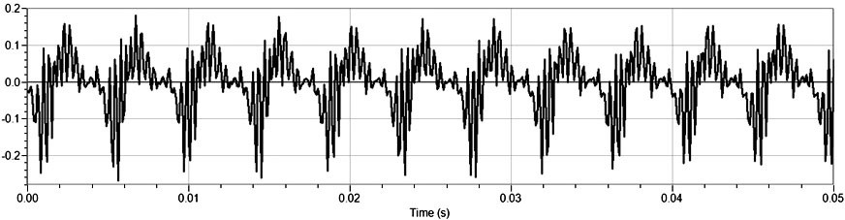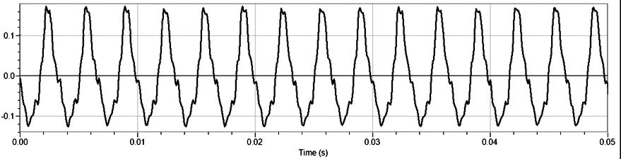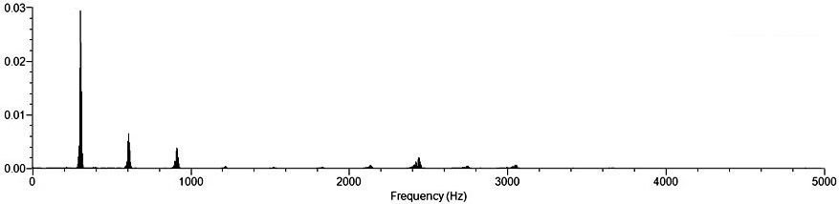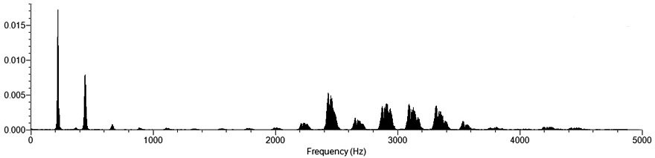The graphs above show the frog-on-post graph and the Fourier analysis of the speech sounds ‘oooh’ and ‘eeeh,’ one in the left column, and the other in the right.
- hich pair is the ‘oooh?’
- the left pair
- the right pair
- How do you know which pair is the ‘oooh?’

- Which pair of graphs shows a sound of a higher pitch? (Hint: Which harmonic determines the pitch?)

- the left pair

- the right pair
- How do you know which pair is the higher pitch?
- For four points, from the graphs above and the Interpreting Sound Spectra PowerPoint show, explain why it’s important that human hearing is most sensitive between about 2,000 and 4,000 Hz.

